MINI PROJECT REPORT
ON

Student Record Management System

Submitted by

ABIRAM M NAIR NC.SC.U4CSE24046

For
23CSE111- Object Oriented Programming II Semester
B.Tech. CSE

School of Computing
Amrita Vishwa Vidyapeetham, Nagercoil

INDEX

Sl.No. | Chapter Name | Page No.
1. | Introduction
2. | Problem Statement
3. | Objectives
4. | UML diagrams of the project  - Class Diagram  - Object Diagram  - Use-Case Diagram  - Activity Diagram
5. | Modules of project
6. | Code
7. | Output Screenshots
8. | Application of the project
9. | Limitations of the project
10. | Bibliography
11. | GitHub link of the project

Introduction
A Student Record Management System is a software application designed to store, manage, and retrieve information about students in an organized manner. It helps schools, colleges, or universities manage student data such as personal information, academic performance, and other records.

Problem Statement

Design and implement a Student Record Management System (SRMS) that can efficiently manage student records in an educational institution. The system should allow administrators, teachers, and authorized users to perform operations such as adding, viewing, updating, deleting, and searching student records. The system should be capable of storing and retrieving student data, including personal details, courses, grades, and other relevant information.

OBJECTIVES:
• Centralized Management of Student Data
• Simplification of Data Entry and Updates
• Efficient Data Retrieval and Search
• Enhanced Security and Access Control
• Grade and Performance Management
• Report Generation
• Data Persistence and Backup
• User-Friendly Interface
• Scalability
• System Efficiency and Performance
• Comprehensive Data Management

UML DIAGRAMS OF THE PROJECT

- CLASS DIAGRAM:
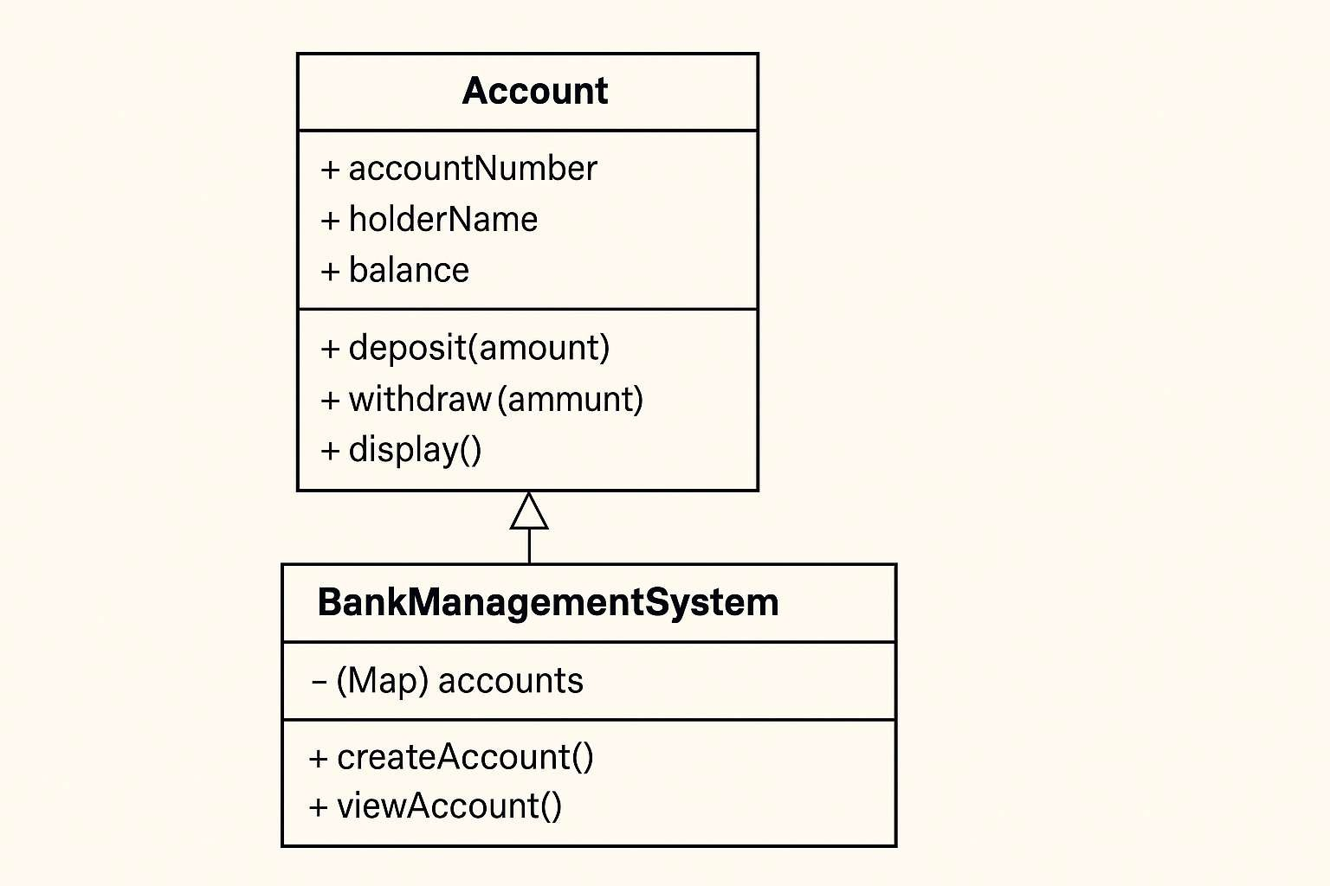
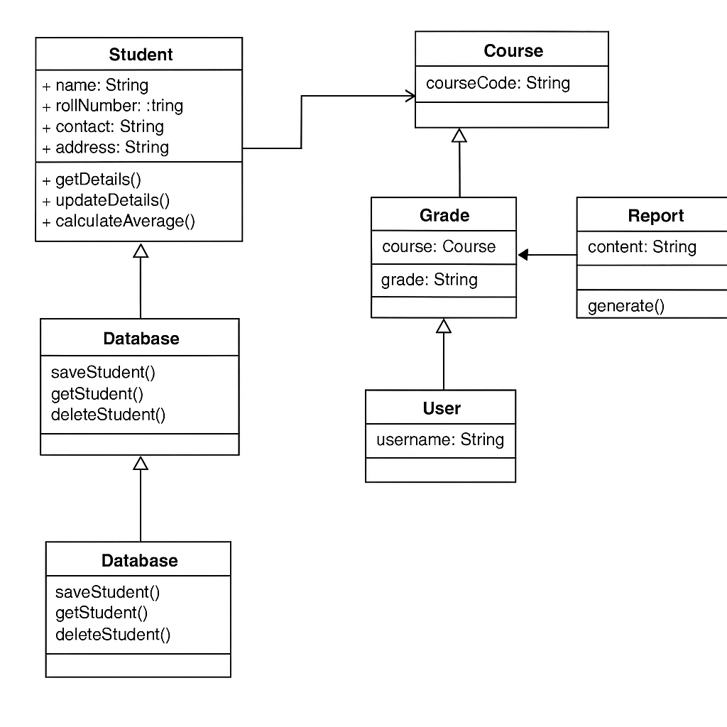
- OBJECT DIAGRAM:
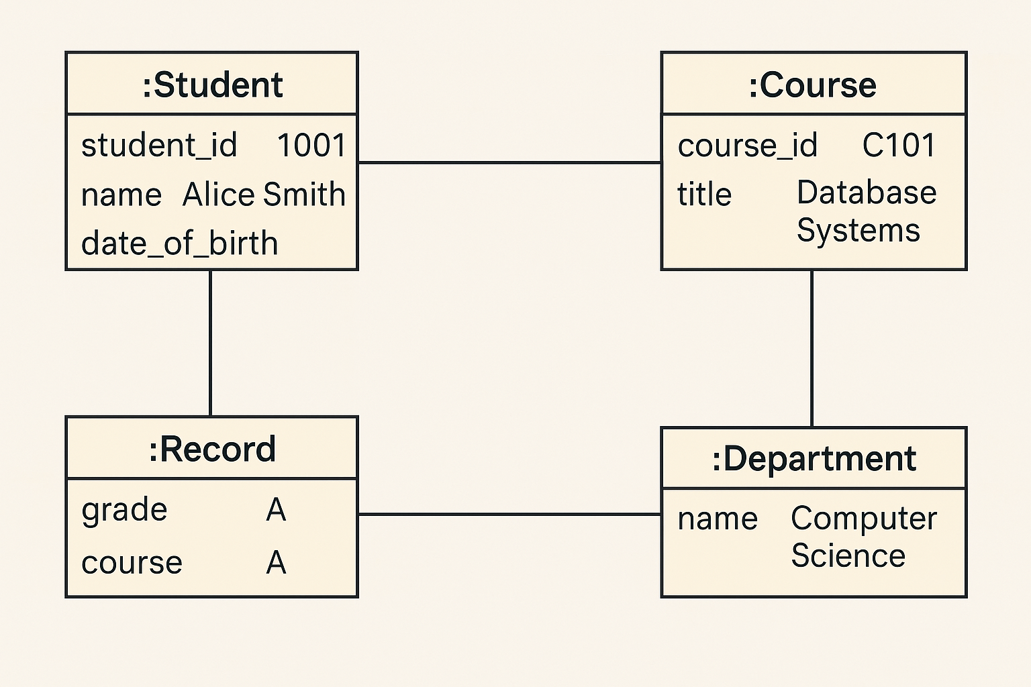
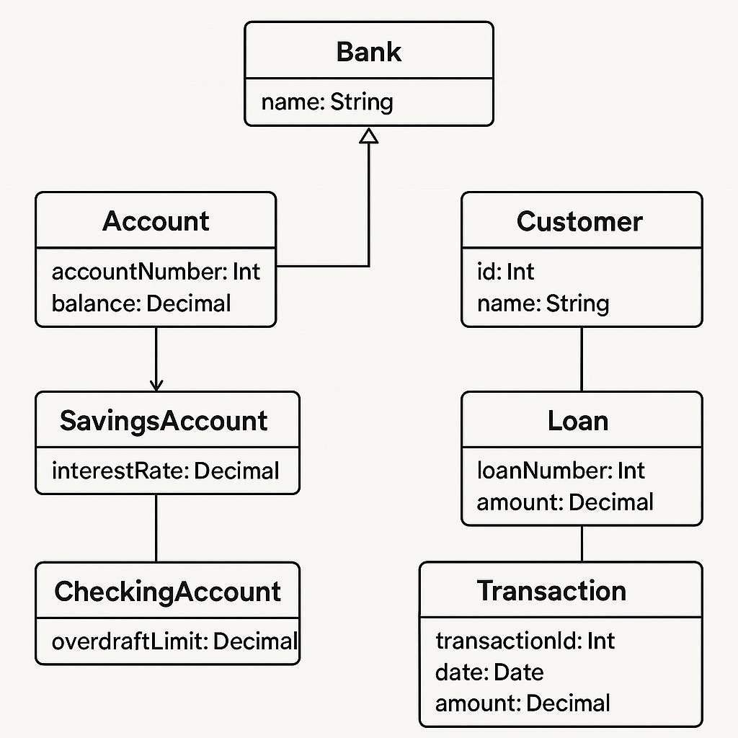

- USE CASE DIAGRAM:
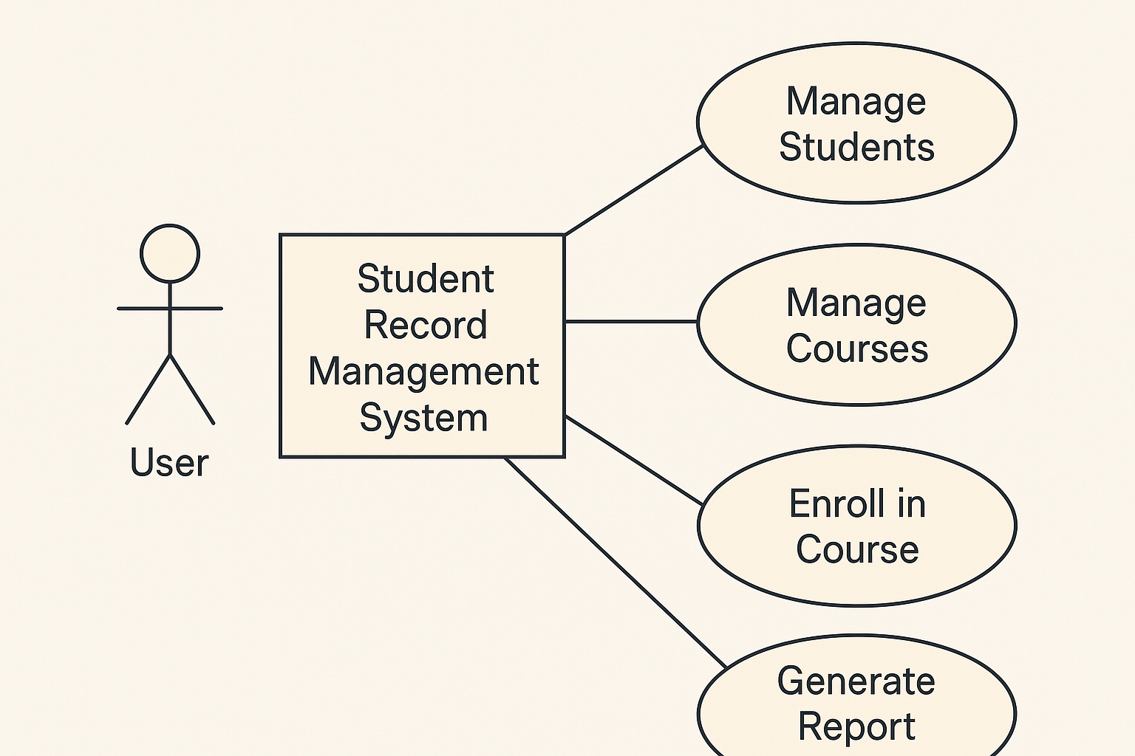
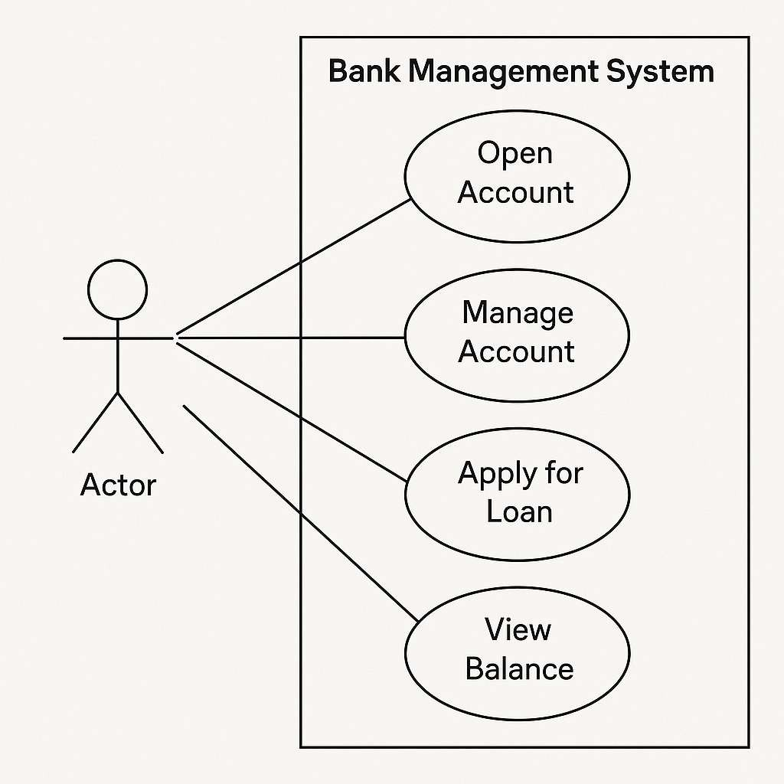

- ACTIVITY DIAGRAM:
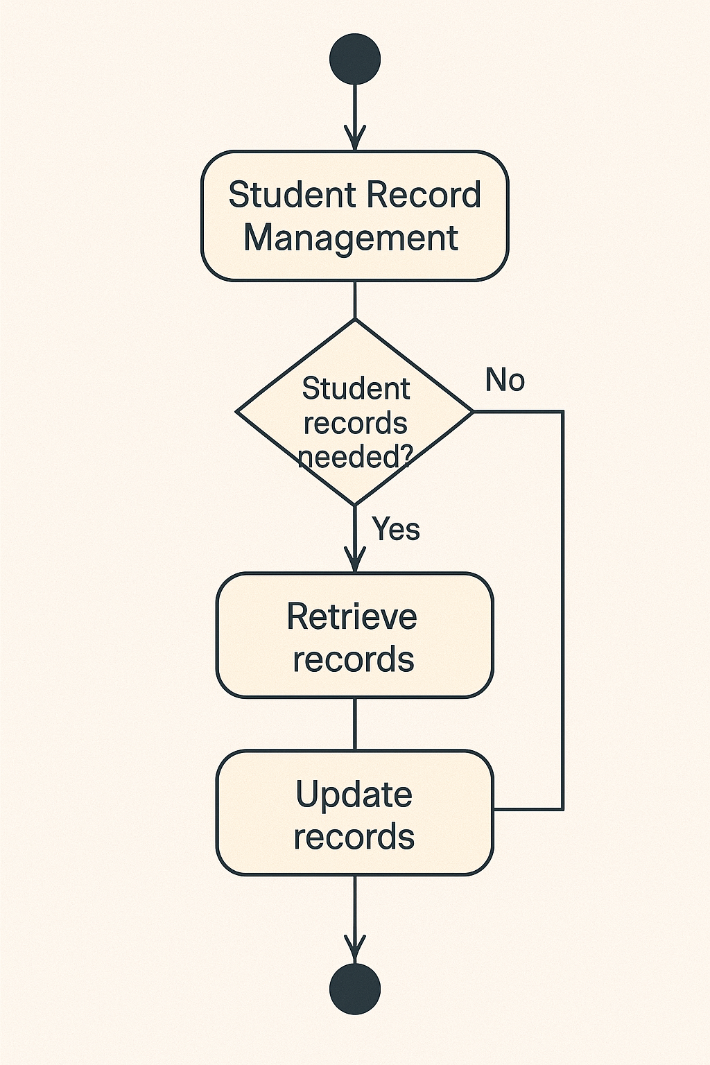

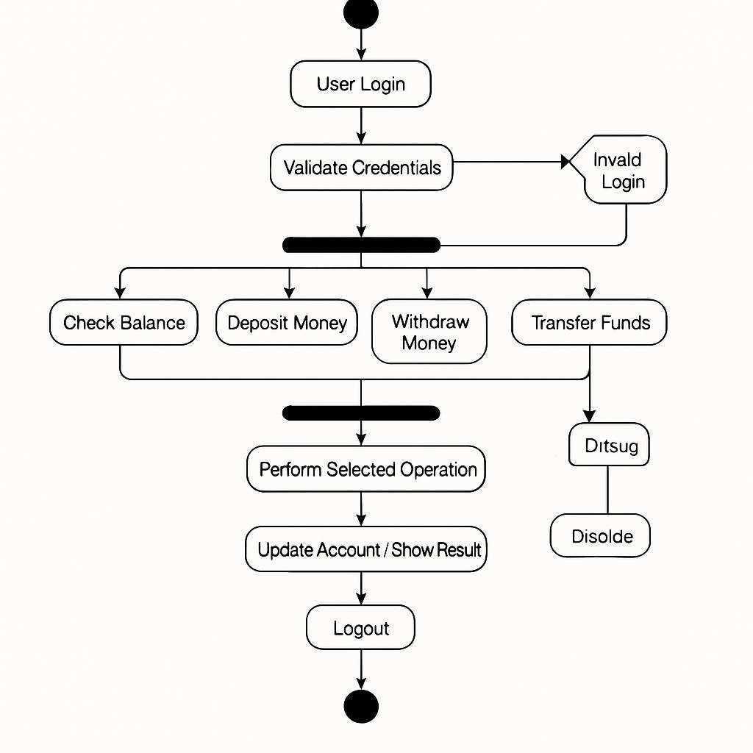

Modules of project :
Login / Authentication Module
- Admin or user login
- User authentication (optional password encryption)
- Role-based access (Admin, Student, etc.)
2. Student Management Module
- Add new student record
- Edit/update existing student record
- Delete student record
- View/search student records
3. Course Management Module
- Add/edit/delete course information
- Assign students to courses
- View course details
4. Marks / Grade Management Module
- Enter marks/grades for students
- Update marks
- Generate reports/transcripts
- Calculate GPA/percentage
5. Attendance Management Module (Optional)
- Mark attendance
- View attendance reports
- Track attendance percentage
6. Search & Reporting Module
- Search by student ID, name, course, etc.
- Generate printable reports (PDF/console output)
- Filter by grades, departments, etc.
7. Database Connectivity Module
- Connect to MySQL or other databases via JDBC
- Perform CRUD operations (Create, Read, Update, Delete)
- Handle exceptions and database errors
8. GUI Module (Optional if not Console-based)
- Java Swing or JavaFX interface
- Forms for input and display
- Menus and navigation
9. File Handling Module (if not using a database)
- Store data in files (CSV, TXT, or JSON)
- Read/write/update student records from files

CODE:

import java.io.*;
import java.util.*;

class Student implements Serializable {
private String studentId;
private String name;
private int age;
private String grade;

public Student(String studentId, String name, int age, String grade) {
this.studentId = studentId;
this.name = name;
this.age = age;
this.grade = grade;
}

// Getters and Setters
public String getStudentId() { return studentId; }
public String getName() { return name; }
public int getAge() { return age; }
public String getGrade() { return grade; }

@Override
public String toString() {
return "ID: " + studentId + " | Name: " + name + " | Age: " + age + " | Grade: " + grade;
}
}

class StudentManagementSystem {
private static final String FILE_NAME = "students.dat";
private List<Student> students;

public StudentManagementSystem() {
students = new ArrayList<>();
loadStudents();
}

// Save students to file
private void saveStudents() {
try (ObjectOutputStream oos = new ObjectOutputStream(new FileOutputStream(FILE_NAME))) {
oos.writeObject(students);
} catch (IOException e) {
System.out.println("Error saving student data: " + e.getMessage());
}
}

// Load students from file
@SuppressWarnings("unchecked")
private void loadStudents() {
File file = new File(FILE_NAME);
if (file.exists()) {
try (ObjectInputStream ois = new ObjectInputStream(new FileInputStream(FILE_NAME))) {
students = (List<Student>) ois.readObject();
} catch (IOException | ClassNotFoundException e) {
System.out.println("Error loading student data: " + e.getMessage());
}
}
}

// CRUD Operations
public void addStudent(Student student) {
students.add(student);
saveStudents();
}

public Student getStudent(String studentId) {
return students.stream()
.filter(s -> s.getStudentId().equals(studentId))
.findFirst()
.orElse(null);
}

public void updateStudent(String studentId, String name, int age, String grade) {
Student student = getStudent(studentId);
if (student != null) {
student.setName(name);
student.setAge(age);
student.setGrade(grade);
saveStudents();
}
}

public void deleteStudent(String studentId) {
students.removeIf(s -> s.getStudentId().equals(studentId));
saveStudents();
}

public List<Student> getAllStudents() {
return new ArrayList<>(students);
}
}

public class Main {
private static Scanner scanner = new Scanner(System.in);
private static StudentManagementSystem sms = new StudentManagementSystem();

public static void main(String[] args) {
while (true) {
System.out.println("\nStudent Record Management System");
System.out.println("1. Add Student");
System.out.println("2. View All Students");
System.out.println("3. Search Student");
System.out.println("4. Update Student");
System.out.println("5. Delete Student");
System.out.println("6. Exit");
System.out.print("Enter your choice: ");

int choice = scanner.nextInt();
scanner.nextLine(); // Consume newline

switch (choice) {
case 1:
addStudent();
break;
case 2:
viewAllStudents();
break;
case 3:
searchStudent();
break;
case 4:
updateStudent();
break;
case 5:
deleteStudent();
break;
case 6:
System.out.println("Exiting...");
System.exit(0);
default:
System.out.println("Invalid choice!");
}
}
}

private static void addStudent() {
System.out.print("Enter Student ID: ");
String id = scanner.nextLine();
System.out.print("Enter Name: ");
String name = scanner.nextLine();
System.out.print("Enter Age: ");
int age = scanner.nextInt();
scanner.nextLine();
System.out.print("Enter Grade: ");
String grade = scanner.nextLine();

sms.addStudent(new Student(id, name, age, grade));
System.out.println("Student added successfully!");
}

private static void viewAllStudents() {
List<Student> students = sms.getAllStudents();
if (students.isEmpty()) {
System.out.println("No students found!");
} else {
System.out.println("\nAll Students:");
students.forEach(System.out::println);
}
}

private static void searchStudent() {
System.out.print("Enter Student ID to search: ");
String id = scanner.nextLine();
Student student = sms.getStudent(id);
if (student != null) {
System.out.println("Student found:\n" + student);
} else {
System.out.println("Student not found!");
}
}

private static void updateStudent() {
System.out.print("Enter Student ID to update: ");
String id = scanner.nextLine();
Student student = sms.getStudent(id);
if (student != null) {
System.out.print("Enter new Name (leave blank to keep current): ");
String name = scanner.nextLine();
System.out.print("Enter new Age (0 to keep current): ");
int age = scanner.nextInt();
scanner.nextLine();
System.out.print("Enter new Grade (leave blank to keep current): ");
String grade = scanner.nextLine();

sms.updateStudent(id,
name.isEmpty() ? student.getName() : name,
age == 0 ? student.getAge() : age,
grade.isEmpty() ? student.getGrade() : grade);
System.out.println("Student updated successfully!");
} else {
System.out.println("Student not found!");
}
}

private static void deleteStudent() {
System.out.print("Enter Student ID to delete: ");
String id = scanner.nextLine();
sms.deleteStudent(id);
System.out.println("Student deleted successfully!");
}
}

OUTPUT SCREENSHOT:
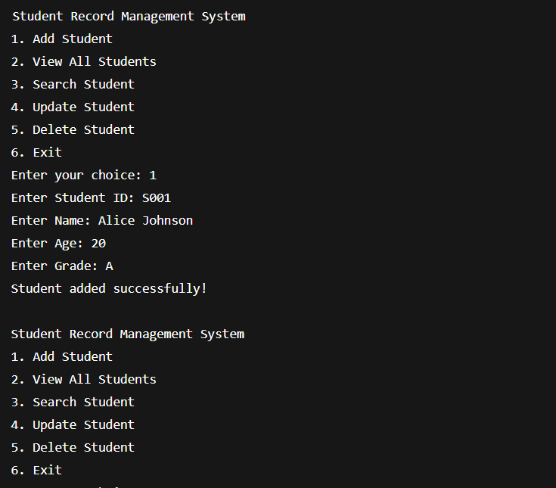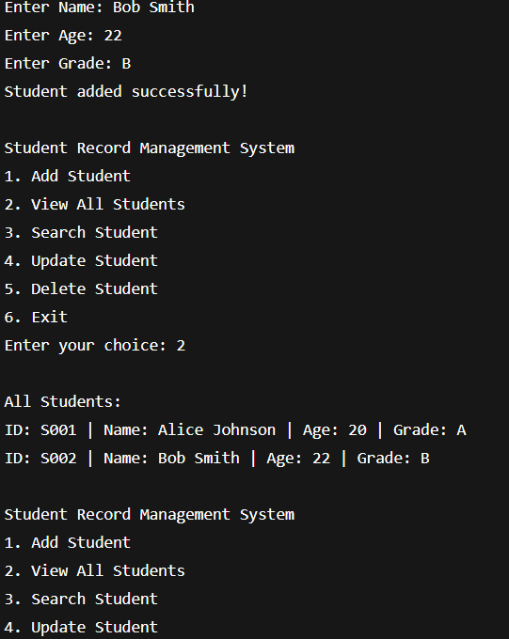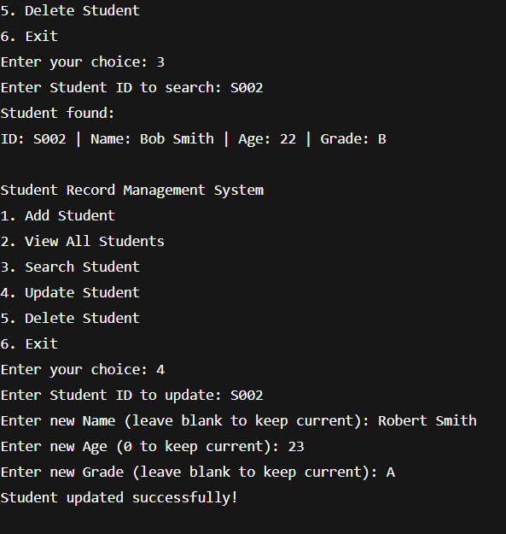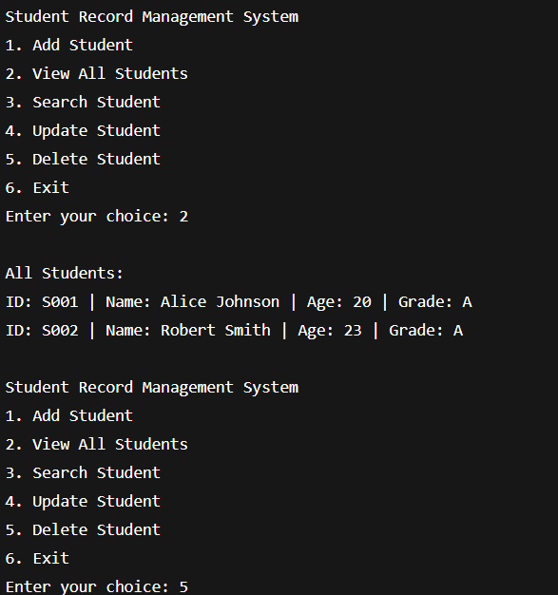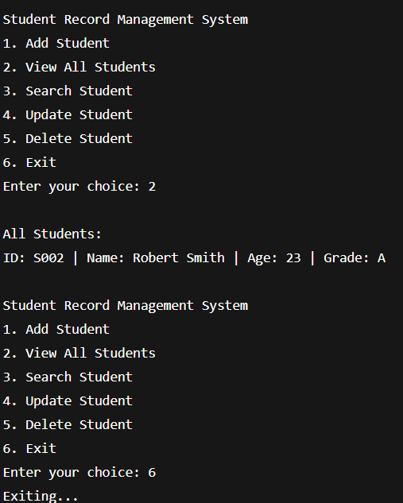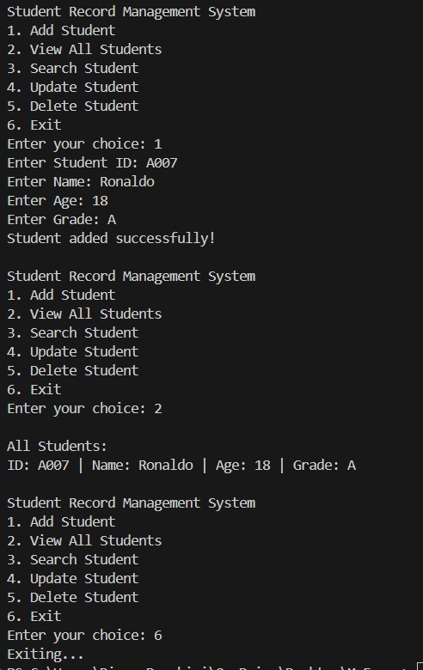

Applications of the Project
Academic Institutions
  - Manage student records like personal details, marks, attendance, course enrollments, and grades efficiently.
Digital Report Generation
  - Automatically generate progress reports, transcripts, and certificates for students.
Admission and Enrollment Process
  - Simplifies new student admission by storing and processing their academic and personal details.
Performance Tracking
  - Helps teachers and administrators track student performance over semesters.
Data Accuracy and Reduction of Errors
  - Reduces human error through automated data entry, retrieval, and updates.
Administrative Automation
  - Automates tasks such as fee status checking, course management, and department-level analytics.
Remote Access
If deployed online, allows students, faculty, and admin staff to access records securely from anywhere.
Audit and Compliance
  - Keeps historical data for auditing, accreditation, or governmental compliance.
Integration with Other Systems
  - Can be integrated with learning management systems (LMS), attendance tracking, and library management software.
Customized Notifications
Send alerts to students about deadlines, grade releases, or course updates.

Limitations of the Project

- Limited Scalability
  - May not perform efficiently with very large datasets unless optimized or upgraded.
- Basic Security Features
  - Without advanced security measures, the system may be vulnerable to unauthorized access or data breaches.
- Lack of Cloud Integration
  - If not cloud-based, the system may not support remote access or real-time updates across devices.
- Manual Data Entry Required
  - Initial data input may still be manual, which can be time-consuming and error-prone.
- No Advanced Analytics
  - The system may not provide deep insights or predictive analytics without additional tools or extensions.
- Limited Role Management
  - May lack advanced role-based access control (e.g., different permissions for admin, teacher, student).
- Dependency on Technical Knowledge
  - Users may need basic technical skills to operate or maintain the system.
- Minimal UI/UX Features
  - The interface may be too simple or not intuitive for all users, especially non-technical staff.
- No Integration with External Systems
  - May not directly connect with payment gateways, biometric systems, or government databases.
- Maintenance Overhead
- Requires regular maintenance and updates, especially in case of bugs or data loss.

Bibliography
- • Java: The Complete Reference
Herbert Schildt, McGraw-Hill Education, 11th Edition
– Used for understanding Java programming concepts and file handling techniques.
- • Head First Object-Oriented Analysis and Design
Brett McLaughlin, Gary Pollice, and David West, O’Reilly Media
– Referred for designing UML diagrams and understanding object-oriented principles.
- • UML Distilled: A Brief Guide to the Standard Object Modeling Language
Martin Fowler, Addison-Wesley
– Used for learning about use case, activity, and object diagrams.
- • Official Java Documentation
https://docs.oracle.com/javase/
– Used for syntax, libraries, and standard programming practices in Java.
- • GeeksforGeeks
https://www.geeksforgeeks.org/
– Helped with Java examples and clarifying core OOP and file handling concepts.
- • TutorialsPoint - Java Programming
https://www.tutorialspoint.com/java/
– Used for reference on basic and advanced Java topics.
- • Draw.io (diagrams.net)
https://app.diagrams.net/
– Used for creating UML diagrams like use case, activity, and object diagrams.

GITHUB LINK OF THE PROJECT:

